SoapLush
Hand and body soap:
- Lavender soap: Lavender soaps has a crisp and clean fragrance with sweet and floral overtones that makes it a favorite among soaps. Its scent is known to promote not only relaxation but also a good mood.

Oils used in the bar soap:
- Olive oil: penetrates deeply into your skin carrying all the vitamins and antioxidants for a youthful and healthy appearance.
- Coconut oil: gives the soap its cleansing and moisturizing power.
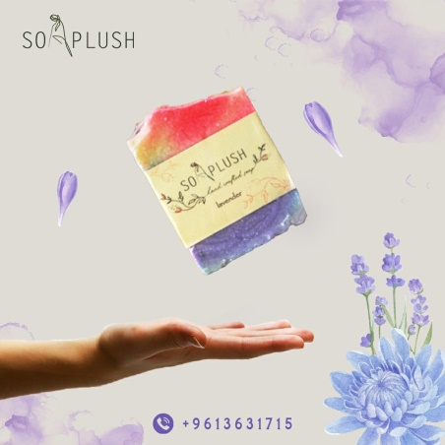
- Palm oil: balances between cleansing and conditioning. Fights aging and sunburns.

Price: 1.5 $

- Jasmine soap: Our Jasmine soap scent is identical to freshly picked Jasmine flowers. This fragrance is bursting with a floral aroma, smells just like summer in a soap bar!

Oils used in the bar soap:
- Olive oil: penetrates deeply into your skin carrying all the vitamins and antioxidants for a youthful and healthy appearance.
- Coconut oil: gives the soap its cleansing and moisturizing power.
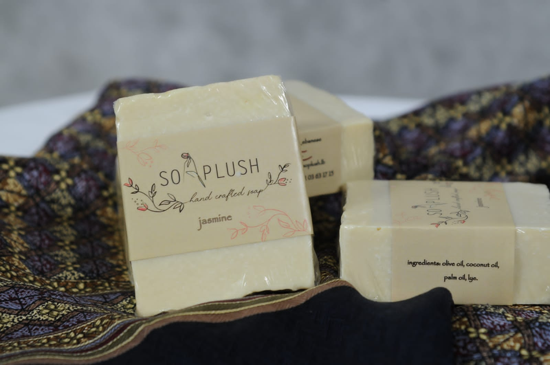
- Palm oil: balances between cleansing and conditioning. Fights aging and sunburns.

Price: 1.5 $
- Rose soap: Our rose soap has a light scent that is both uplifting and inspiring. This touch of fragrance will create a warm and romantic aroma to keep you coming back again and again.

Oils used in the bar soap:
- Olive oil: penetrates deeply into your skin carrying all the vitamins and antioxidants for a youthful and healthy appearance.
- Coconut oil: gives the soap its cleansing and moisturizing power.
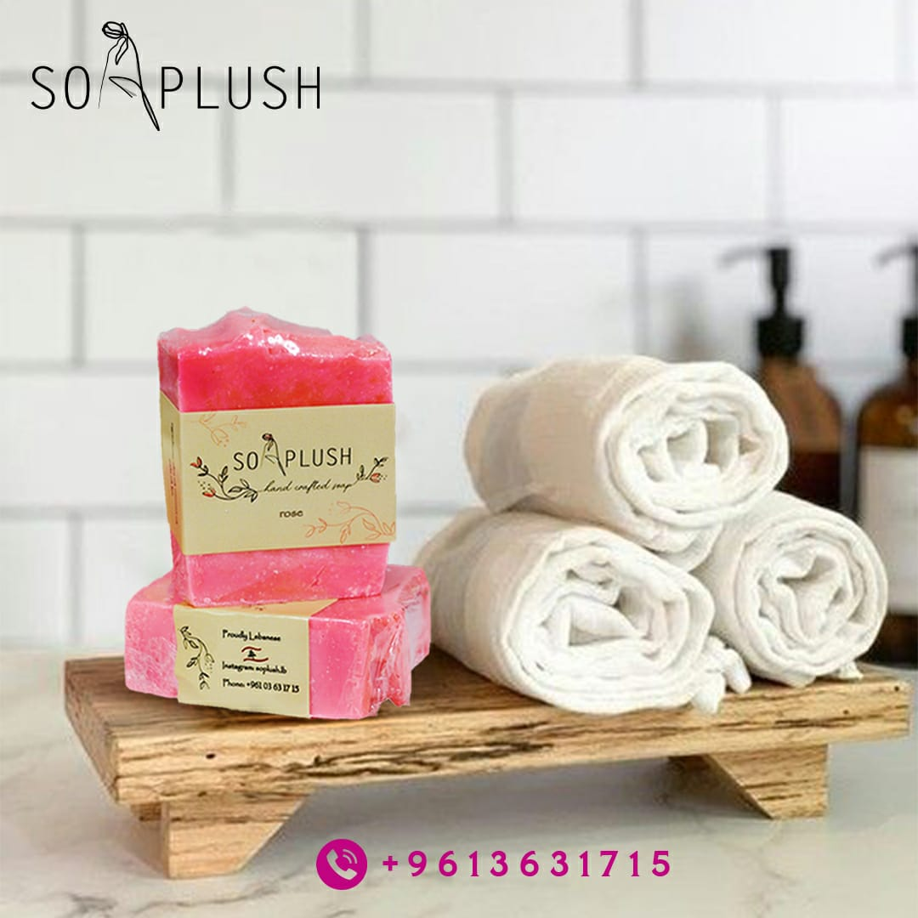
- Palm oil: balances between cleansing and conditioning. Fights aging and sunburns.

Price: 1.5 $

- Laurel: Aside from its amazing quality as a soap bar, it has the softest aroma that can fill your heart. Its clean and crisp fragrance always triggers your nostalgia for old Lebanese traditions.

Oils used in the bar soap:
- Olive oil: penetrates deeply into your skin carrying all the vitamins and antioxidants for a youthful and healthy appearance.
- Coconut oil: gives the soap its cleansing and moisturizing power.
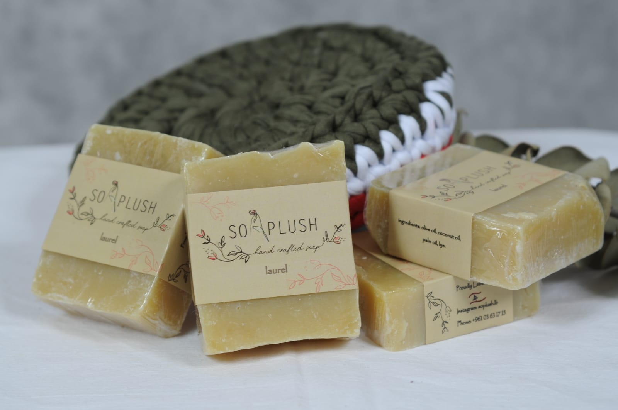
- Palm oil: balances between cleansing and conditioning. Fights aging and sunburns.

Price: 1.5 $
- Pine: This fresh scented soap will remind you of walking through a pine grove. It is like taking a breeze from Mount Lebanon pines. Nourishing and moisturizing leaving your skin feeling soft.

Oils used in the bar soap:
- Olive oil: penetrates deeply into your skin carrying all the vitamins and antioxidants for a youthful and healthy appearance.
- Coconut oil: gives the soap its cleansing and moisturizing power.
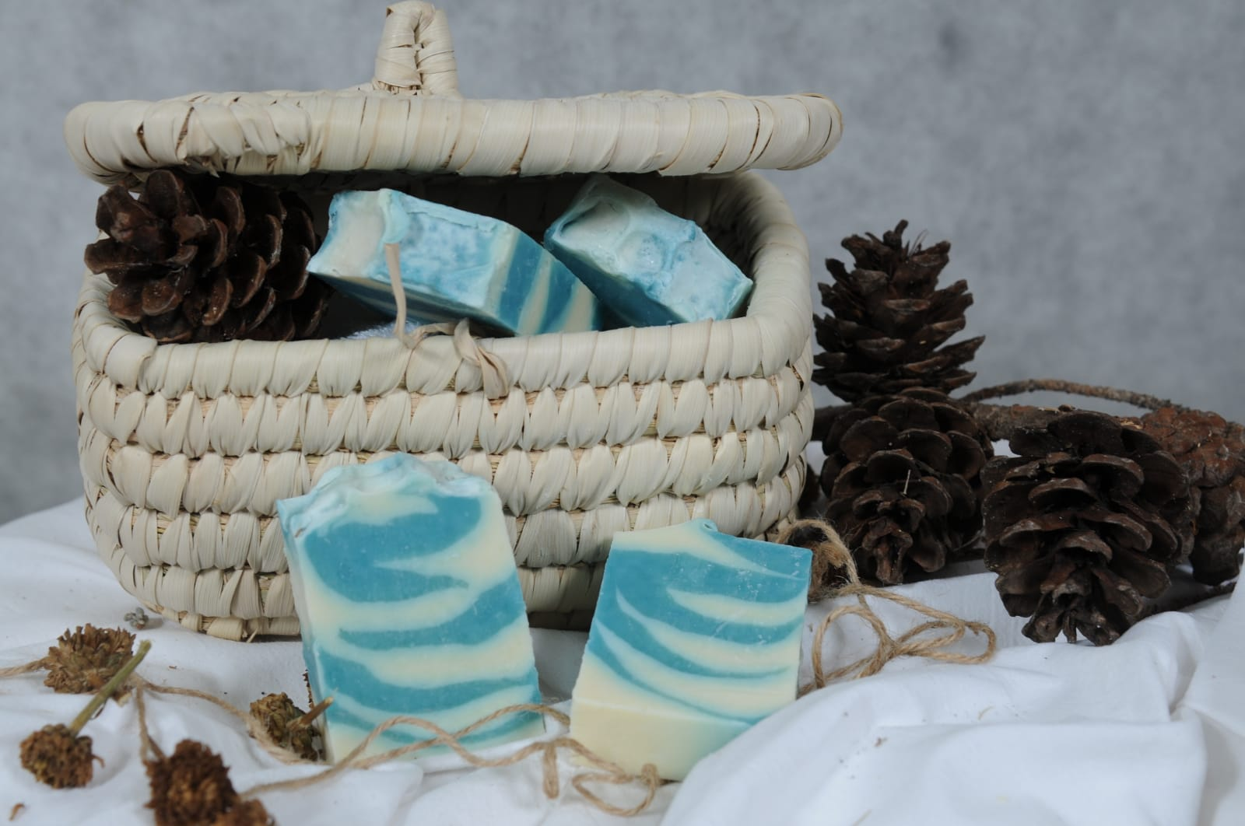
- Palm oil: balances between cleansing and conditioning. Fights aging and sunburns.

Price: 1.5 $

- Chamomile soap: it has lot of benefits for skin. Good for acne and eczema, calms any kind of irritation your skin might be experiencing. Along with hydrating and moisturizing your skin, it also adds radiance.

Oils used in the bar soap:
- Olive oil: penetrates deeply into your skin carrying all the vitamins and antioxidants for a youthful and healthy appearance.
- Coconut oil: gives the soap its cleansing and moisturizing power.
- Palm oil: balances between cleansing and conditioning. Fights aging and sunburns.

Price: 1.5 $

- Mountain spring: Light, fresh, citrusy, with hints of balsam and floral notes, this scent is like a breath of fresh air on a crisp Spring morning in the mountains.

Oils used in the bar soap:
- Olive oil: penetrates deeply into your skin carrying all the vitamins and antioxidants for a youthful and healthy appearance.
- Coconut oil: gives the soap its cleansing and moisturizing power.
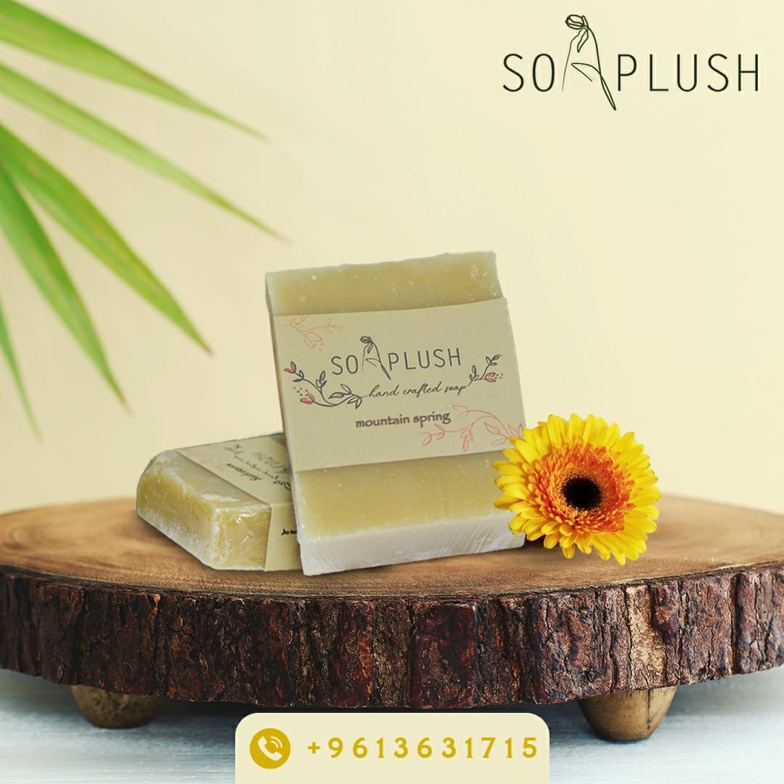
- Palm oil: balances between cleansing and conditioning. Fights aging and sunburns.

Price: 1.5 $

Facial soaps:
- Aloe Vera soap: An anti-bacterial healing formula with a blend of vitamin-enriched oils, aloe Vera gel and glycerin.
All together give your face a repaired, healthy and smooth appearance.

Aloe vera gel: known for its anti-bacterial and healing properties. Repairs damaged skin caused by drying and cracking from frequent washing. Sanitizes and soothes the skin leaving it clear and healthy.

Glycerin: preserves your skin’s natural moisture making it delicate and smooth.

Oils used in the bar soap:
- Olive oil: penetrates deeply into your skin carrying all the vitamins and antioxidants for a youthful and healthy appearance.
- Coconut oil: gives the soap its cleansing and moisturizing power.
- Palm oil: balances between cleansing and conditioning. Fights aging and sunburns.
- Castor oil: anti-bacterial and anti-inflammatory.
- High levels of vitamin E, minerals, proteins, omega 6 and 9.
- Reduces black heads.
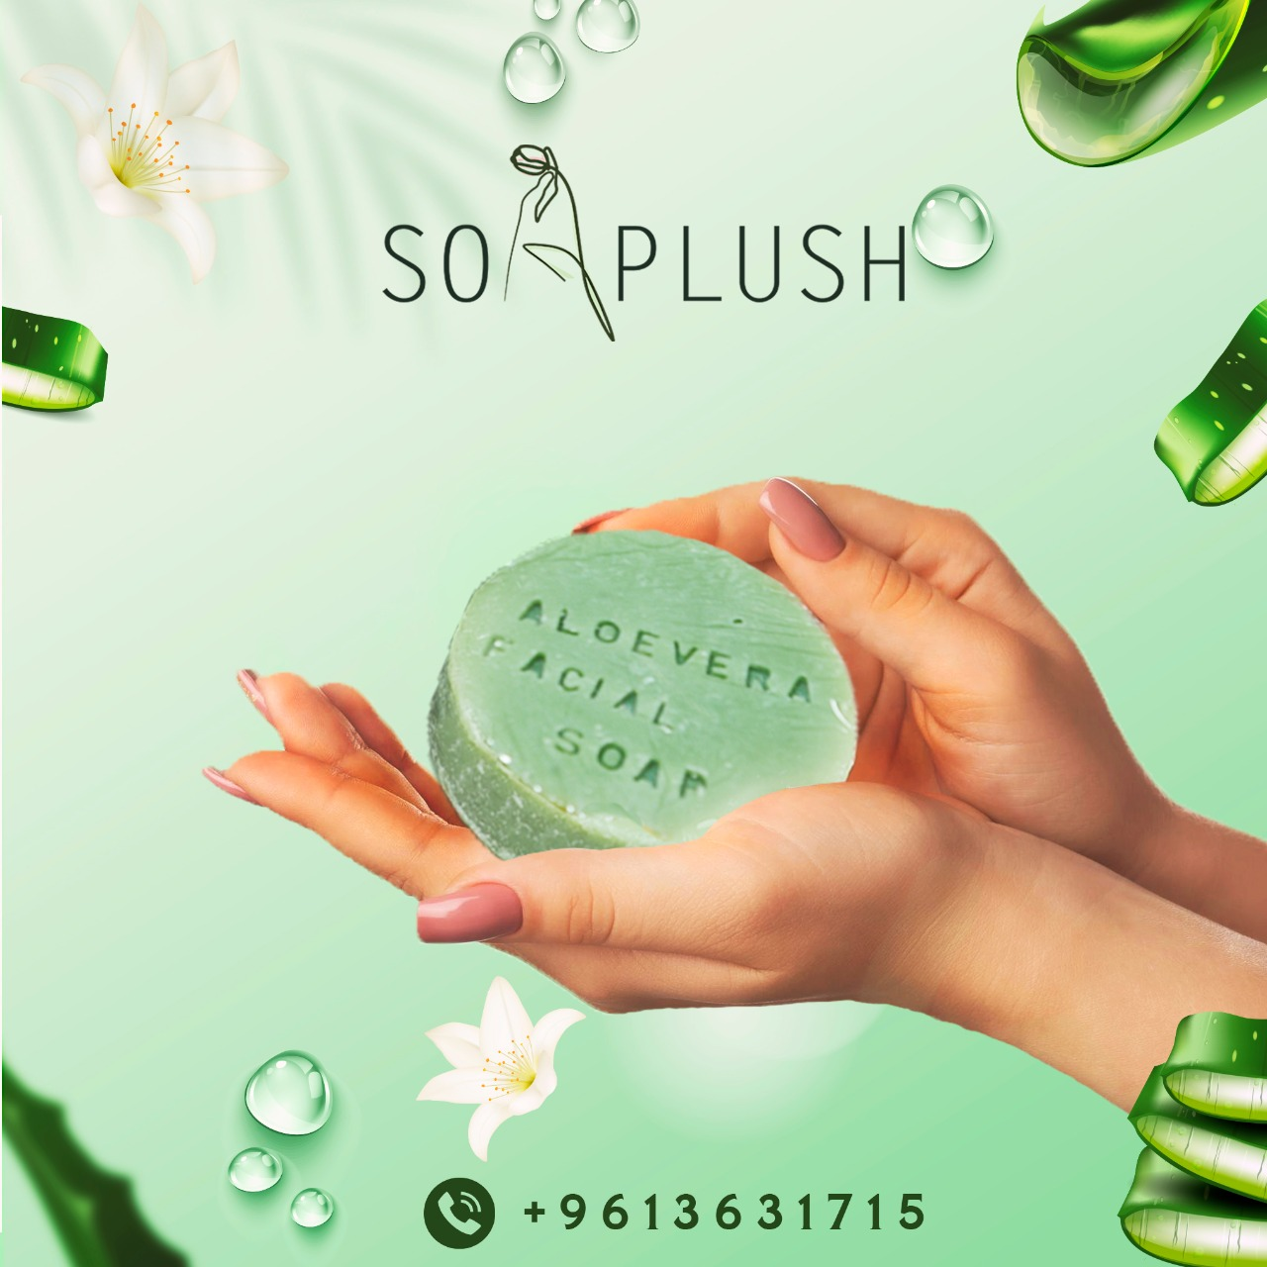
- Dissolves and washes away sebum (oily secretions produced by the skin), replacing it with new clean oil.

Price: 1.5 $

- Charcoal and honey soap: Our charcoal & honey soap is a super cleansing, anti-aging and moisturizing power; all together in a bar of soap!!!

Activated charcoal: absorbs toxins and excess oils. Helps better cleanse the skin. Skin pores become less visible and smaller and blackheads start to disappear. Exfoliate the skin.

Honey: known for its moisturising and antimicrobial qualities.
Reduces fine lines and wrinkles to regain a radiant skin. Acts deeply to restore skin elasticity.

Glycerin: preserves your skin’s natural moisture making it delicate and smooth.

Oils used in the bar soap:
- Olive oil: penetrates deeply into your skin carrying all the vitamins and antioxidants for a youthful and healthy appearance.
- Coconut oil: gives the soap its cleansing and moisturizing power.
- Palm oil: balances between cleansing and conditioning. Fights aging and sunburns.
- Castor oil: anti-bacterial and anti-inflammatory.
- High levels of vitamin E, minerals, proteins, omega 6 and 9.
- Reduces black heads.
- Dissolves and washes away sebum (oily secretions produced by the skin), replacing it with new clean oil.

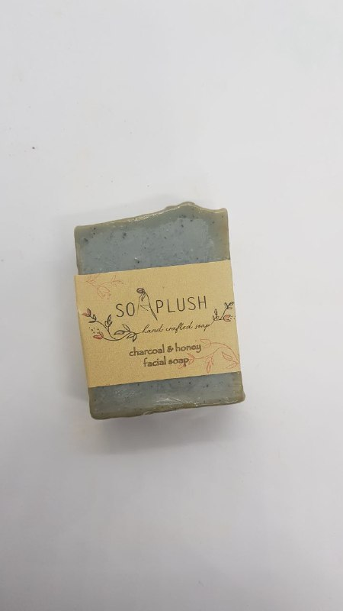
Price: 1.5 $

